Tri Wood Open Golf & Dinner Registration

Resurrection Catholic Church

Invites You and Your Guest to Attend

Our 11th Annual Golf Fundraiser

Tri Wood Open

**When**: Saturday September 13, 2025

**Where:** Villa Olivia 1401 W Lake St. Bartlett, IL 60103

630/289-1000

Registration: Begins at 10:30 ~ Shotgun Start at Noon

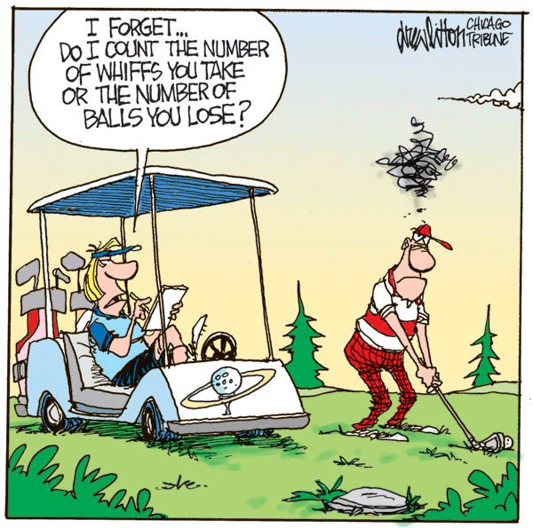

May your Swing be STRAIGHT

And the ball fly FAR

May your round be BLESSED

With no worse than PAR!

On Course Events, Raffles & Silent Auction!

**Golf & Dinner**: ~18 holes of Golf, Cart, Dinner~ $110.00

**Golf Only**: $ 85.00

**Dinner Only**: Adult(s) $ 40.00

Kid(s) 12 & under $ 20.00

***2 ways to register:*** Online: rescatholic.org **or** complete the information on the back of this form, return it to the parish office or place it in the collection basket.

Golf & Dinner Registration

**# Of People**

Golf & Dinner ________ x $110 = ________

Golf Only ________ x $ 85 = ________

Adult Dinner Only ________ x $ 40 = ________

Kid Dinner Only ________ x $ 20 = _________

**Total Due**: ________

Contact Person _______________________________________

Phone # ________________________________________

Email Address: _________________________________________

**If you are playing in a foursome, please list the first and last names of those in your group:**

Golfer #1 ___________________________________________________________________

Golfer #2 ____________________________________________________________________

Golfer #3 _____________________________________________________________________

Golfer #4 ______________________________________________________________________

Adult Dinner Only Name(s) _____________________________________________________

______________________________________________________

______________________________________________________

______________________________________________________

Kid Dinner Only Name(s) _______________________________________________________

_______________________________________________________

All Proceeds from this fundraiser will be used to support our Parish’s Capital Improvement!!!